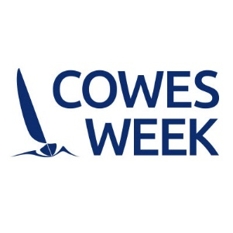

**Cowes Week Official Charity for 2017 Regatta**

Cowes Week feels that by appointing one official charity to be an integral part of the event, fundraising activities can be conducted in a focused way. There is now an opportunity for charities to nominate themselves to be considered as the official event charity for the next 1 year term (2017) with an option to extend by one further year.

We invite applications from national charities with direct relevance and a meaningful link to sailing, including:

* Charities that use sailing as a fundamental part of their rehabilitation programme.
* Charities that seek to help disadvantaged people develop physically and mentally through sailing.
* Charities that provide support to sailing as a sport, hobby or vocation.

Please note:

* Applications need to be submitted by 17:00 on Monday 24th October 2016 to Kristen Lloyd [Kristen.lloyd@cowesweek.co.uk](mailto:Kristen.lloyd@cowesweek.co.uk) Please find attached an application form for completion.
* By the end of October, a shortlist of charities will be put forward for consideration by Cowes Week Ltd.
* Charities that are shortlisted must be available for interview on 3rd November 2016 at Regatta House, Cowes.

**In line with the outlined requirements, please provide detailed answers to the following questions:**

**Name & registered charity number:_____________________________________________**

|  |  |
| --- | --- |
| 1. Date organisation was established? | **<please type in responses here>** |
| 1. Describe the work of the charity (100 words max). |  |
| 1. **Please provide an outline of the activities you would plan to have in place throughout Cowes Week to support your charitable objectives and fundraising activities. How will your activities support and have a positive impact on the local community?** |  |
| 1. How do you feel your charity fits in with the spirit of Cowes Week? |  |
| 1. In what ways do you see your charity benefiting from an involvement with Cowes Week? |  |
| 1. Please outline how funds raised through an association with Cowes Week would be used to the benefit of the charity? How will success be monitored and evaluated and how frequently? |  |
| 1. Do you have any charity “ambassadors/ patrons”, and if so who? Would they attend the event in support of your activities? |  |

Continued …

|  |  |
| --- | --- |
| 1. Do you have any close working relationships with other companies e.g. sponsors of the charity etc. and, if so, who? |  |
| 1. Please include any additional information that you feel may be relevant to your application. |  |

Please return the application form to:

Kristen Lloyd

Cowes Week Ltd

Regatta House

18 Bath Road

Cowes

Isle of Wight

PO31 7QN

T: 01983 248001

E: [kristen@cowesweek.co.uk](mailto:kristen@cowesweek.co.uk)